1. Consider a Poisson point process with rate lambda=1 on the real line. Let N(t) be the random variable that the number of points over [0,t). Generate such a point process in Matlab and plot two realizations of N(t) versus t. Do the same for lambda =2.

2.

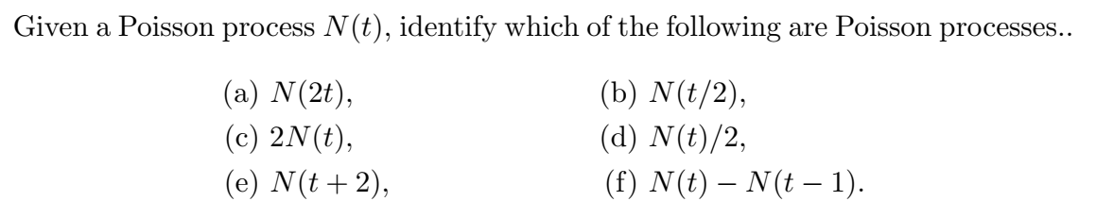

3. (**10.5.5**)

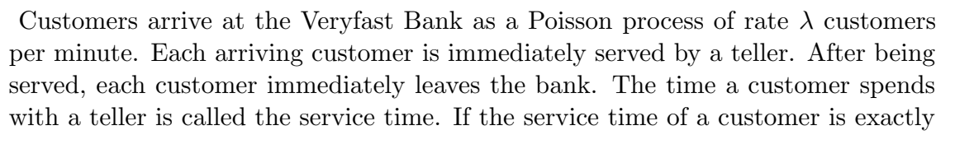



4. (**10.6.1**)

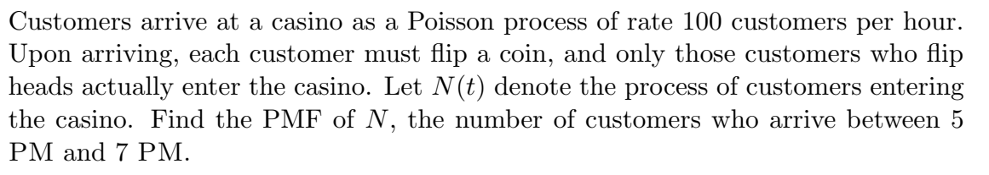

5. (**10.4.3**)

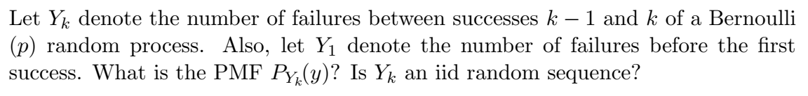

6. (**12.1.1**)

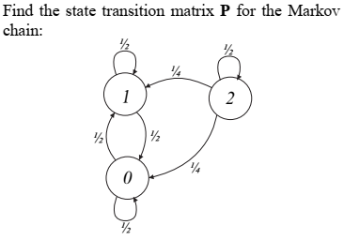

7. (**12.1.2**)

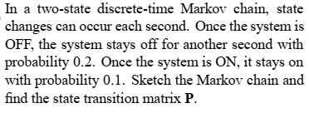

8. (**12.1.6**)

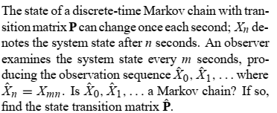

9. (**12.5.5**)

